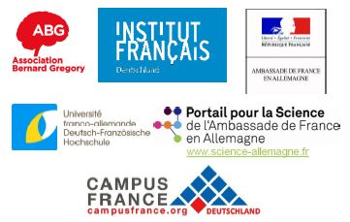

Webinar: French-German Researchers’ Day
Zoom, July 9, from 2pm to 5pm

Speakers (by alphabetical order)
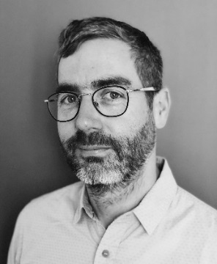
After graduating from the Ecole Nationale Supérieure de Chimie de Paris (E.N.S.C.P.), Stéphane Baudron obtained his Ph. D. from the University of Angers, France, under the supervision of Dr. Patrick Batail in 2002. Following a two-year post-doctoral stay in the group of Prof. Jeffrey R. Long at U.C. Berkeley (USA) supported by a Lavoisier fellowship, he was appointed C.N.R.S. researcher at the University of Strasbourg, France, in 2004. He obtained his habilitation in 2009 and was promoted research director in 2019. He has received a fellowship from the Japan Society for the Promotion of Science (JSPS) for a research stay in the group of Prof. Susumu Kitagawa in Kyoto and an USIAS fellowship. His interests are in coordination and supramolecular chemistry, and novel reaction media.

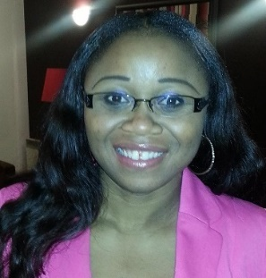
Janique Bikomo is project manager at the DAAD (German Academic Exchange Service) office in Paris, where she coordinates research scholarships for PhD students, Postdocs, and more senior academics and scientists. She holds a Master’s degree in translation (Japanese-German-French), media studies and German as foreign language from the University of Bonn, Germany. She started working with the DAAD in 2009 where she managed different scholarships programmes and projects at the main office of the DAAD in Bonn, before joining the DAAD office in Paris in 2016.

About the DAAD (German Academic Exchange Service)
The DAAD is the world’s largest funding organisation for the international exchange of students and researchers.

Since it was founded in 1925, around two million scholars in Germany and abroad have received DAAD funding. It is a registered association and its members are German institutions of higher education and student bodies. Its activities go far beyond simply awarding grants and scholarships. The DAAD supports the internationalisation of German universities, promotes German studies and the German language abroad, assists developing countries in establishing effective universities and advises decision makers on matters of cultural, education and development policy.
Its head office is in Bonn, but the DAAD also has an office in the German capital, Berlin, to which the famous Berlin Artists-in-Residence Programme (Berliner Künstlerprogramm) is closely affiliated. It maintains contact with and provides advice to its main partner countries on every continent via a network of information centres and regional offices such as the regional office in Paris.

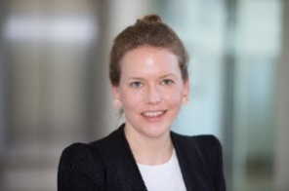
My name is Eva-Maria Hengsbach and I work at the Franco-German University (FGU) in the department “degree programs and graduation”. I’m responsible for our funding programs for doctoral students, so the Franco-German graduate schools and the instrument “Cotutelle de these”.

Pierre Passot, Research and Technology Strategic Partnership Management at Airbus
I am 53 years old, originally from the Grenoble region in France. With a technical background, I started my career on Computer Aided Design (CAD) area, first at Dassault Systèmes, then in Nexter company as CAD Administrator for the Group. Quickly I went back to technic, still at Nexter, taking part and then leading the development deployment of naval military embedded systems. In 2003 I took responsibility for the Electromechanic Design Department at EADS Defense Electronics. In 2006, I joined Airbus Commercial as first Project manager, then in cross-functional activities for the development of Lean in Airbus engineering and Airbus digital transformation. I joined the Airbus Research department 1 year ago, in charge of French non-industrial strategic partnerships.

Jessica Cohen, PhD in political sciences, Officer Strategic Relations and Academic HR Development at Berlin Institute of Health

Cyriac Massué, PhD in inorganic chemistry, Policy Officer at Federal Ministry of Economy and Energy

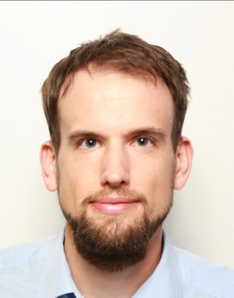
Tobias Rödel, PhD in physics, Senior Editor at Nature
Tobias was born in a small village in Northern Bavaria, Germany, and received his M.Sc. in ‘Technology of Nanostructures’ at the University of Würzburg. His studies included a yearlong research internship at the University of Berkeley. His PhD at the University Paris-Saclay was focused on condensed matter physics. A short postdoc at the University of Luxembourg was based on the growth and characterization of thin films for photovoltaic and detector applications. In 2017, Tobias left academia and now works as an editor at the scientific journal ‘Nature’ where he handles manuscripts on condensed matter physics.

